COUNTY/CITY OF -------
BUILDING DEPARTMENT

A Homeowner’s Guide to
Submitting Building Plans Understanding Building Plans And
Building Inspections
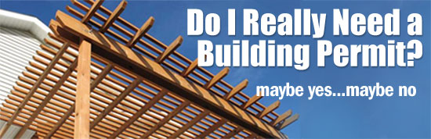

TABLE OF CONTENTS
Introduction 2
Is a Permit Required? 3
Plan Preparation 5
Submittal for Plan Review 6
Permit Issuance 7
Requesting Inspections 8
The Inspection Process 8
Plan Changes 8
Inspections 9
Avoiding Permit Expiration 10
Final Approval 10
Summary 11

INTRODUCTION

This brochure is intended to provide basic information for homeowners wishing to design and/or build a new home or add an addition to and/or remodel an existing home. It is not a complete list of County/City codes and regulations but is intended to provide answer to the questions most frequently asked of the Building Department by interested homeowners.

Residential buildings are typically constructed using what is called “conventional construction” by the California Residential Code. This method utilizes materials and techniques that have been proven through long periods of usage to be adequate for residential buildings. Information provided in this brochure is based upon the “conventional construction” parameters of the most current edition of the California Building Code (which is based on the most current edition of the International Building Code). Specialized engineered structural systems or techniques that were used in your existing home or unusual features of your proposed home may require design by a State of California licensed Professional Engineer or Architect.

IS A PERMIT REQUIRED?

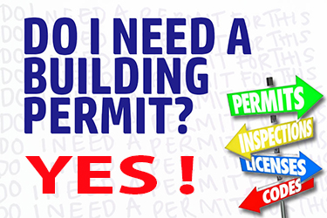

Most construction work requires a permit and additional inspections to help assure that unsafe conditions are not created.

There are certain exceptions to this rule. These include:

- One-story, detached accessory structures used as tool and storage sheds, playhouses, and similar uses, provided the floor area does not exceed 120 square feet.

- Wood, chain link and wrought iron fences not over 7 feet high.

- Retaining walls without a surcharge that are not over 4 feet in height measured from the bottom of the footing to the top of the wall.

- Water tanks supported directly on grade if the capacity does not exceed 5,000 gallons and the ratio of height to diameter or width does not exceed 2:1.

- Sidewalks and driveways.

- Painting, papering, tiling, carpeting, cabinets, counter tops and similar finish work.

- Prefabricated swimming pools accessory to a Group R-3 occupancy that are less than 24 inches deep, do not exceed 5,000 gallons and are installed entirely above ground.

- Swings and other playground equipment accessory to detached one-, and two-family dwellings.

- Window awnings supported by an exterior wall that do not project more than 54 inches from the exterior wall and do not require additional support.

- Listed cord-and-plug connected temporary decorative lighting.

- Minor electrical repair work, including the replacement of lamps or the connection of approved portable electrical equipment to approved permanently installed receptacles.

- The clearing of stoppages or the repairing of leaks in pipes, valves
or fixtures and the removal and reinstallation of water closets, provided such repairs do not involve or require the replacement
or rearrangement of valves, pipes or fixtures.

- The stopping of leaks in drains, water, soil, waste, or vent pipe, however, if any concealed trap, drainpipe, water, soil, waste or vent pipe becomes defective and it becomes necessary to remove and replace the same with new material, such work shall be considered as new work and a permit would be required.

- Portable heating appliances; portable ventilation equipment; portable cooling units; and portable evaporative coolers and replacement of any minor parts of mechanical systems that does not alter its approval or make it unsafe.

Although a permit may not be required, there may be other zoning regulations that apply. For instance, the Planning Department may regulate fence heights and locations. If you are uncertain about your project, a telephone call or visit to the Planning Department before commencing work may save some time and headaches.

PLAN PREPARATION
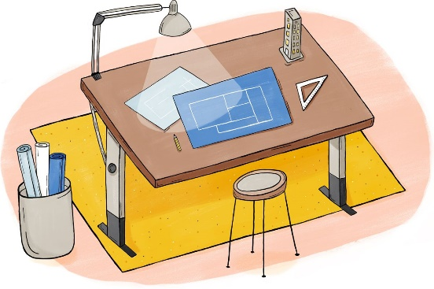
The key to obtaining a permit with the shortest delays and the least amount of frustration lies in the proper preparation of plans. Plan preparation should show specifically what is to be done, where on your property it is to be done, and how the project will be constructed. An accurate drawing is the only practical way of creating mutual understanding and expectations between you, the Building Department office staff and the field inspector.

If you have doubts that your project/plan may not be approved, preliminary information can be obtained at the Building Department office counter during plan preparation. Often a few minutes of conversation and a sketch can save redrawing of plans by resolving concerns before final working drawings are completed.

Often building departments require, a site plan of your property showing the location of the work accompany the building permit application. A site or plot plan is a view of your entire property looking down from above. It must include all property lines, all structures located on the property, the street, the driveway and the location of any proposed work to be done. A sample site plan is shown attached to this booklet (and one may also be obtained at any of our front counters).

In addition to the required site plan, the size and complexity of your project will determine how extensive your plans must be. Changing out windows or adding electrical outlets may only require existing room uses, dimensions and window sizes. A patio or similar structure will require a drawing or sketch showing how the structure will be built, including the size and spacing of structural members and the methods intended to be used in making the connections of the structure and attachments to the existing building and the size of the footings. To assist you; the Building Department has standard drawings available on the department’s website at www.tustinca.org and at our public counter for patios covers, block walls, window replacement and EV Chargers.

If you are planning to construct a new home, or just a room addition, additional plans prepared by a California registered architect or civil/structural engineer may be required. Certain State of California requirements are extremely complex, and typically beyond the capabilities of the average homeowner. These State requirements alone make obtaining professional help advisable. General residential plan submittal requirements and room addition requirements are available on our website.

SUBMITTAL FOR PLAN REVIEW
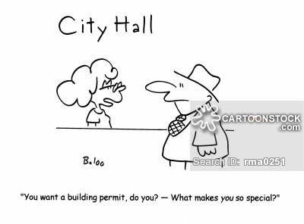
Four complete sets of plans must be submitted for plan check to the Building Department. One set of plans will be returned to you at the time of permit issuance as your approved copy.

Additional information:

- You will need the legal description of your property (lot and tract number). This can be obtained from your property tax bill or deed.

- You will be asked to fill out an application to construct for your building permit. You will need to specify the type of work proposed. The square footage and use of new buildings or additions is required. The property owner, architect, engineer, applicant or licensed contractor information including address and telephone number is required on the application form. You can obtain an application form from our website or at the office counter.

- When plans are required (including site plans) a plan check fee must be paid at the time of permit application.

- Applications for permit for any proposed work for which no permit is issued shall expire 360 days after the date of filing. Extension of time for action by applicant is granted once for 180 days.

PERMIT ISSUANCE
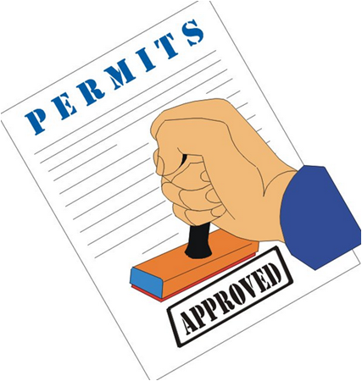
After all required departments have approved the plans, a permit to construct may be issued. At the time of permit issuance certain fees may be required that are specific to your project. A preliminary estimate of fees is advisable before the expense and effort of final plan preparation is undertaken. We urge you to contact the Building Department for more information.

The permit may be issued to a California licensed contractor or a homeowner. When your building permit is issued, a copy of the approved plans will be returned to you and an inspection Job card. The plans and card are to be kept at the job location and must be available for the inspector’s use whenever they visit your property for inspections. With your permit in hand you are now ready to proceed with construction.

REQUESTING INSPECTIONS
Inspections may be scheduled in person at the Building counter, or by phone at (714) 573-3141. Alternatively, submit a request online for inspection by visiting the Inspection Request Page. Make sure that when you request an inspection you include your name and phone number where you can be reached along with the permit number, the job address, and the type of inspection that you are requesting.

THE INSPECTION PROCESS
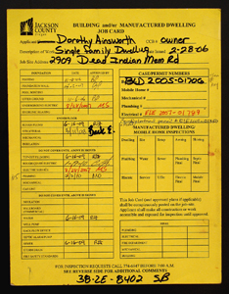
When the building inspector visits your project, the approved plans must be available for comparison with the work, and the inspection card must be available for the inspector’s signature if the work passes the inspection. If there are corrections to be made before approval, the inspector will leave a “correction notice” briefly outlining the things required to be completed prior to approval of that portion of the project. Time delays and re-inspections can be avoided if you make sure that work is complete before the inspector arrives. Any necessary tests should have been done ahead of time to assure acceptance and compliance.

Your inspector can provide you with a lot of useful information about the codes and inspections but cannot act as a construction supervisor. If you are not reasonably familiar with construction procedures it may be to your advantage to hire a licensed contractor or tradesperson to do the work or assist you.

PLAN CHANGES
If you decide during the construction process that a change is desirable, it is necessary that a plan change be approved through the Building and Safety Department office staff. This can sometimes be done over the counter, but if building area or structural features are to be modified it may be necessary to perform additional plan checking and/or that an additional permit fees may be required. If you have questions regarding a need for plan change approval, call and ask.

INSPECTIONS
During construction of your project the majority of contacts with the Building and Safety Department will be through the field inspection staff when they visit your property.

City building regulations require that certain inspections be made prior to covering that portion of construction, for example, a framing inspection before drywall is applied. On typical residential construction this means that you must request inspections at certain stages of the project before proceeding. These inspection stages typically are as follows:

  - Foundation inspection: To be made when trenches have been excavated, forms are set, and all steel reinforcing, hold down hardware and/or anchor bolts are in place.

  - Concrete slab or underfloor inspection: To be made after all in-slab or under-floor equipment, piping, conduit, etc. are in place, but before the concrete is placed or floor sheathing installed.

  - Roof sheathing and shear panel-nailing inspection: To be made when the roof sheathing and shear panels are installed and entirely nailed off.

  - Framing inspection: To be made after all framing, fire blocking, and bracing are in place; all pipes, chimneys and vents are complete, roof covering is in place, rough electrical wiring, plumbing piping, and heating ducts are installed and fire sprinkler system approved by Fire Department when required.

  - Insulation inspection: To be made when all insulation is installed, and all openings and gaps in the shell of the building have been caulked or sealed.

  - Lath and/or gypsum board inspection: To be made after all lathing and gypsum board, interior and exterior, is in place and nailed but before plaster has been applied or before gypsum board joints and fasteners have been taped and finished.

  - Final inspection: To be made after finish grading, building is complete and ready for occupancy, and all plumbing and electrical fixtures and appliances are installed.

Other inspections may be required as well as those outlined above. For instance, pressure tests are necessary for water and gas piping, and water tests of drainage and sewer piping are likewise required. The inspectors
may also advise you of the need for additional inspections if they believe special attention is required for some areas of your project.

AVOIDING PERMIT EXPIRATION
Every permit issued by the building official under the provisions of the California Building Code, shall expire by limitation and become null and void if the building or work authorized by such permit is not commenced within 180 days from the date of such permit. Your permit expires in 180 days if no inspections are made within 180 days, or if you have not received an approved inspection within 180 days.

Before such work can be continued, a new permit shall be obtained. If new building codes become effective during expiration, the new permit and building plans may be subject to the new requirements.

Prior to expiration and upon written request, only one 180-day extension may be granted.

FINAL APPROVAL
If your project has conditions of approval from other departments that are not yet met, those approvals will be required prior to requesting final inspection from Building Department. To obtain approvals for your project, call the Building Department and request information regarding these conditions.

After the building inspector makes his inspection, and all requirements have been satisfied, your project will be approved. If a new electric or gas service has been installed as a part of your project and approved by the inspector, they will see that the utility company is notified. Note: you must also call and arrange for installation of the electrical meters from the utility company.

SUMMARY
We have attempted in this pamphlet to provide useful, but very general information. To ensure that your project proceeds without any delays, consider the following:

- Ask for a preliminary review of what you propose before you develop working drawings.

- Plan carefully. Make sure plans are complete and clearly indicate what you are going to do, where you are going to do it and how you propose to do it.

- If you do not have basic design or construction skills, consider getting help from professionals.

- Call for inspections ahead of time and recheck your work before the inspector arrives, thereby avoiding callbacks, or additional cost based on the deposit-based fee method.

- Coordinate final inspection with Planning, Public Works or Fire Departments and with the serving utilities.

We want to be helpful to you during your construction project. We urge you to utilize the services of the Building Department, when you need guidance or have questions as you proceed through the building experience.

Together we can make your efforts more productive and less frustrating.

Remember, when in doubt, give us a call and ask for help. It is easier and more satisfying when we can prevent a problem before it develops.

