County of San Diego, Planning & Development Services

HOW TO OBTAIN A BUILDING PERMIT SUMMARY

BUILDING DIVISION

The purpose of this guidance document is to help customers better understand the building permit process by summarizing the basic steps. This document is intended as a guide only. Forms referenced in this document contain supplemental information and are available on the County website. (This document does not specifically address code enforcement projects; which will require additional steps. Please consult with your code enforcement officer to discuss processing of these projects, if applicable.)

Building permits may be applied for at the Planning & Development Services (PDS), Building Division:
5510 Overland Ave., Suite 110, San Diego, CA 92123-1666
Office Hours: 8:00 AM – 4:00 PM Monday through Friday
(858) 565-5920

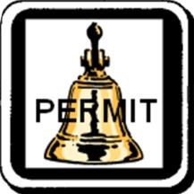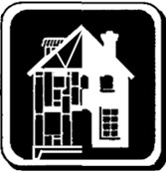

Contact information for Zoning, Land Development, and Department of Environmental Health (DEH) Counters:
Zoning Counter Land Development Counter DEH Counter
(858) 565-5981 (858) 694-2055 (858) 565-5173

BUILDING PERMITS
Building permits are required by California law to ensure public health, safety and general welfare and to protect life and property. A permit is required to construct, enlarge, alter, convert (including change of occupancy, use, or character), repair, move, or demolish a structure. Permits are also required for grading, plumbing, electrical, and mechanical work. Permits must be obtained prior to construction. For a list of work exempt from permit, see Permit Requirement Exceptions (form BD 110).
In accordance with the provisions of the California Business and Professions Code, the plans for all buildings and structures shall be prepared and each sheet shall be signed by a person licensed by the State of California as a civil engineer, structural engineer, or architect. See Who May Prepare Plans (form PDS 118) for a list of exemptions to this requirement that may be permitted.

PERMIT, IMPACT & AGENCY FEES
The building permit and inspection program is funded entirely by fees and does not receive revenue from taxes. Plan check and permit fees are calculated based on the cost of providing the service. Fees vary depending on the nature and scope of the project.
In addition to building permit and plan check fees, most permits require other fees not administered by the Building Division including impact fees (transportation impact fees (TIF), park fees (PLDO), flood control, etc.) and agency fees (school fees, fire mitigation fees, sewer & water, etc.) that must be collected prior to issuance. These impact and review fees can be a sizeable amount.

PROCESSING TIME
Overall processing time to obtain a new single family dwelling building permit is typically six months to one year from submittal to issuance of the permit. Plan check turnaround times for “log-in” plan checks vary due to workload. Typical backlog time for initial plan check after application submittal and payment of plan check fees is approximately four weeks for residential projects and six weeks for commercial projects. Overall processing time between initial submittal and permit issuance is often prolonged due to multiple re-check cycles. About half of projects submitted require more than two plan check cycles. The best way to save time in the process is by submitting quality plans, thoroughly addressing all plan check correction items, and by returning plans for re-check in a timely manner.
5510 OVERLAND AVE, SUITE 110, SAN DIEGO, CA 92123 ● (858) 565-5920 ● (888) 336-7553 HTTP://WWW.SDCPDS.ORG

BASIC BUILDING PERMIT PROCESSING STEPS
For most projects, the following steps must be completed before a building permit can be issued.
Step 1:  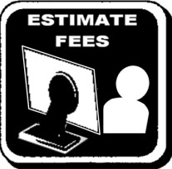 | - It is strongly encouraged that you explore and estimate fee costs prior to preparing plans.  - Building Construction Permit Fees (form PDS 613) or Building Plan Check and Permit Fee Estimator Spreadsheet: Building Forms and Handouts - Fees Section  - Park Fees (PLDO): http://www.sdcounty.ca.gov/PDS/bldgforms/pldo_fees.html  - Transportation Impact Fees (TIF): https://gis-public.co.sandiego.ca.us/TIFCalculator/Default.aspx
Step 2: | - Obtain evidence of a legal lot at the Zoning counter. A parcel must have been legally created and the owner must provide evidence. (See Determination of Legal Parcel, Policy  G-3)  - Consult with DEH, Zoning, Fire, and Land Development for requirements which may affect the proposed project (i.e., flood, special area designations, route locations, septic, etc.).  - Determine setback requirements (Zoning, Fire, Department of Public Works, etc.).
Step 3: | - Prepare plot plan. (See Minimum Plot Plan Information, form PDS 090)  - Prepare two complete sets of building plans and supporting documents (including structural calculations, truss drawings, energy calculations, etc.) based upon code requirements, zoning regulations, and other provisions (e.g., DEH, DPW, Fire). (See Minimum Essential Plan Submittal Items for Single-Family Dwellings and Accessory Structures, form PDS 658.)
Step 4:  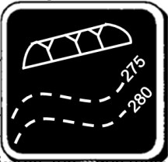 | - If your project requires a PDS minor grading permit pursuant to the County Grading Ordinance, prepare grading plans on the PDS Grading Plan Template (cover and supplementary sheet), GRDPDS and GRDPDS2. (See Minimum Requirements for Grading Plans, form PDS 173 and Minor Grading Plan Checklist, form PDS 009)  - For large grading (L-Grade) projects, please contact Land Development for requirements.
Step 5:  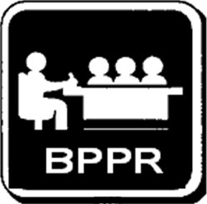 | ❑ Bring building plans (and minor grading plans, if applicable) and all supplemental information to the Building Plan Pre-Submittal Review (BPPR) counter and obtain BPPR approvals (Zoning, Building, Land Development, and DEH).
Step 6:  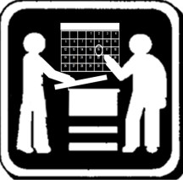 | - Schedule an appointment for project submittal as required by BPPR.  - Some minor projects with quality drafted plans may be eligible to be processed “over the counter” (OTC) without an appointment at the discretion of the Building Division staff. OTC projects are reviewed at the counter while you wait, but typically require plan corrections and/or outside agency clearances. In most cases, at least one return visit is necessary.
Step 7:  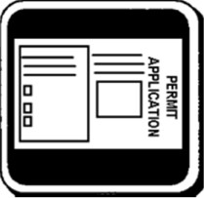 | - Complete the Building Permit Application (form PDS #291) and, if applicable, the Grading Permit Application (form PDS #352). Applications are available at the Building Division.  - Completely fill out the applicant’s portion of the application(s).  - If the property owner is to construct the project, read and complete Owner-Builder Information and Verification, form PDS 421.
Step 8:  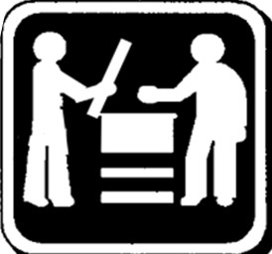 | - Return to the Building Division at the scheduled appointment time.  - Submit building plans and permit application. Allow at least one hour for project submittal.  - If a minor grading permit is needed, submit grading plans and grading permit application after submitting your building permit application. Process grading separately per the Conditions of Approval. Rough grading inspection must be approved prior to building permit issuance.

Step 9: | ❑ Receive plan check fee invoice. (See Building Construction Permit Fees, form PDS 613)  Pay plan check fees. Plan check will not begin until the balance is paid in full.
Step 10:  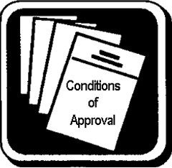 | - Read all documents received at plan submittal, including the conditions of approval. All conditions of approval must be completed prior to issuance of the building permit. See Sample Conditions of Approval (form PDS 712) for a list of potential conditions which may apply.  - A plan check is valid for one calendar year from the date the plans are submitted. If the plan check expires, the plans must be resubmitted and a new plan check fee paid.
Step 11: | ❑ Obtain required clearances as specified by the conditions of approval. Several of these items should be addressed soon after plan submittal, including:  - DEH review of septic or sewer  - Clearance letters for school, water, and sewer agencies ▪ Other conditions identified
Step 12: | ❑ Plans are reviewed by County staff for compliance with codes and ordinances and
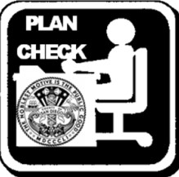  PLAN  CHECK | correction lists are generated by the following County specialties (as required):  - Engineer (Structural) ▪ Electrical, Plumbing, and Mechanical  - Planner ▪ County Fire Marshal (if not in fire district)
Step 13: | - The project contact person on record will be notified when the plans have been reviewed and are ready to be picked up.  - Pick up plans and correction lists from the Building Division counter.
Step 14: | - Correct all noted deficiencies on the plans per the correction list(s) and any red/blue marks identified on the plans.  - Prepare a thorough response list to each correction list describing where and how all correction items were addressed on the plans.  - Re-print corrected plans and retain original plan-checked sets.
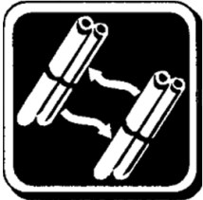Step 15: | ❑ Return corrected plans, old plans, correction list(s), and response list(s) for recheck.  Repeat steps 9 through 12 (as required) until all corrections are approved.
Step 16:  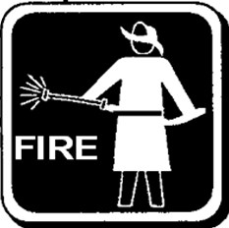 | - For projects not reviewed by the County Fire Marshal, submit plans approved by County specialties (engineer, planner, etc.) to the applicable fire district for review. For fire district contact information see the San Diego County Fire Authority web site. A contact list is provided in the Fire Plan Check Forms section located under ‘Prevention.’  - Obtain fire district approval and stamps on the plans and a completed fire mitigation form.  - If fire review necessitates plan revisions, return to the County for approval stamp transfers.

Step 17: | - Return signed-off correction lists and stamped, approved plans to the Building Division.  - Submit evidence that all conditions of approval for permit issuance have been satisfied.  - The Land Use Technician at the Building Division counter reviews the conditions of approval and submitted evidence to ensure all conditions have been satisfied.
Step 18: | - Permit invoice is issued.  - Pay applicable fees, including any or all of the following:  - Building permit fees ▪ Drainage fees  - Transportation impact fees ▪ Fire mitigation fees  - Park fees ▪ Sanitation district fees | - Water district fees  - Other
Step 19:  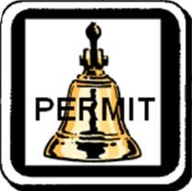 | - Permit is issued.  - Receive building permit, stamped and perforated approved set of plans and supporting documents, and an Inspection Record card (form PDS #291B). Each of these items must be kept at the building site and available to the inspector while the project is under construction.
Step 20: | ❑ Commence construction and call for inspections. To request an inspection, call our office during business hours or the 24-hour inspection request hotline (800) 351-2551 (see Instructions for 24-Hour Inspection Hotline, form PDS 598). In most areas of the County, notice of at least one working day is required for inspections. We may not be able to provide next day inspections in some remote areas.
Step 21:  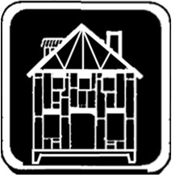 | - A County building inspector must approve each part of the subsequent construction.  - Once construction begins, an inspection must be requested – and construction progress demonstrated – every six months for a building permit to remain active. Permits have a maximum duration of three years. Expired permits may be renewed for a percentage of current fees, but the project may be subject to new regulations in effect at the time of renewal.
Step 22:  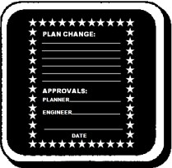 | - Projects must be constructed as shown on the approved plans. Any changes to the project must be submitted to County staff, reviewed, and approved before commencing work.  Inspections will be delayed until the plan change process is complete.  - See the Plan Change Guidance Document (form PDS 803) for more information.
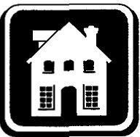Step 23: | - All required inspections (including final inspection) must be passed to obtain a Certificate of Occupancy. (See Final Residential Inspection Requirements, form PDS 117)  - A separate document will not be provided to signify Certificate of Occupancy. The completed, signed-off permit card is the Certificate of Occupancy and should be retained.

These forms and many others are available online at the County’s web site at the Building Forms and Handouts page (http://www.sdcounty.ca.gov/pds/bldgforms/index.html)

