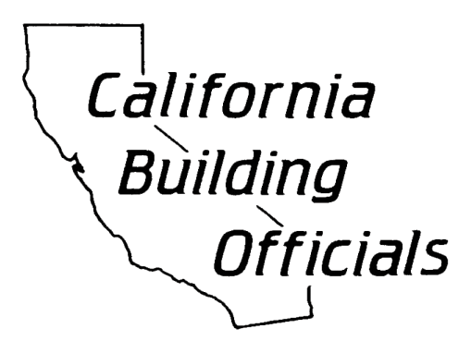

AB 1236 Staff Report Template
for Large Jurisdictions

To: Honorable Mayor and City Council / Honorable Board of Supervisors

From: Name, Community Development Director or Building Official

Subject: Adopt an Ordinance amending Chapter __________ of the City of __________ Municipal Code / County of __________ County Code by setting forth an expedited, streamlined permitting process for electric vehicle charging stations as required by Government Code Section 65850.7.

Recommended Action
Staff recommends that the City Council:
Introduce for first reading the attached ordinance which sets forth an expedited, streamlined permitting process for electric vehicle charging stations.

Executive Summary
In 2015, the State of California adopted Assembly Bill 1236 (2015, Chiu, Codified as Government Code Section 65850.7), which requires local jurisdictions with a population of 200,000 or more residents to adopt an ordinance to create an expedited, streamlined permitting process for electric vehicle charging stations on or before September 30, 2016.

An electric vehicle charging station is any level of electric vehicle supply equipment station which deliver electricity from a source outside an electric vehicle into a plug-in electric vehicle. AB 1236 may refer to the recommendations in the most current version of the “Plug-In Electric Vehicle Infrastructure Permitting Checklist” of the “Zero-Emission Vehicles in California: Community Readiness Guidebook” published by the Governor’s Office of Planning and Research.

Background
Assembly Bill 1236, which amended Government Code Section 65850.7 to require jurisdictions with a population of 200,000 or more residents to establish procedures for expedited, streamlined processes for permitting of electric vehicle charging stations. The amendments to Section 65850.7 include the requirement for a jurisdiction to adopt an ordinance for the expedited, streamlined process on or before September 30, 2016. The ordinance shall include the requirement that a jurisdiction adopt a checklist of requirements with which a permit application for an electric vehicle charging station will be eligible for expedited review.

This process includes the establishment of a checklist containing objective requirements for the installation of an electric vehicle charging station and a process for electronic submittal of permit applications. The content of the checklist requires the permit applicant to check the features of the existing electrical service such as rating in amperes, system voltage, connected or calculated load, spare capacity in amperes, voltage and ampere rating of the electric vehicle supply equipment, circuit rating of the electric vehicle supply equipment, location of the electric vehicle supply equipment, if ventilation is/or is not required, and clearances of the charging equipment to comply with all applicable building and fire safety laws. The checklist also assists the applicant in confirming that the location of the electric vehicle supply equipment will comply with any vehicle clearance requirements in the City’s / County’s Zoning Ordinance. Section 65850.7 requires that the City’s / County’s checklist may be based on the “Plug-In Electric Vehicle Infrastructure Permitting Checklist” of the “Zero-Emission Vehicles in California: Community Readiness Guidebook” of the Governor’s Office of Planning and Research.

Assembly Bill 1236 (2015) also clarifies that a jurisdiction shall not condition approval of a permit for an electric vehicle charging station based on the approval of an association as defined in California Civil Code, Section 4080.

Staff recommends that City Council / County Board of Supervisors introduce for First Reading the attached ordinance, given Government Code Section 65850.7’s requirement that local agencies adopt such an ordinance to create an expedited, streamlined permitting process for electric vehicle charging stations on or before September 30, 2016. Most of the procedures, such as electronic submittal of plans are currently in place and comply with the requirements of the Assembly Bill and staff is assuring that successful implementation of an expedited, streamlined process will be available to permit applicants by September 30, 2016.

Building and Safety Commission Action
The Building Officer and Fire Marshal held a public meeting with the Building and Safety Commission on ________, 2016 where the Commission heard staff’s proposed procedures for an expedited, streamlined process for electric vehicle charging stations. The Commission provided comments regarding balancing the requirement for expedited processing while verifying the fire, life and safety aspects of electric vehicle charging stations and maintenance of public protection. Staff intends for the application and checklist process to create a standardized system of issuing permits for compliant installations. Staff assured the Commission that all requirements of fire-life-safety will be verified during the review and inspection for the electric vehicle charging stations.

The Commission’s action was a recommendation to approve the ordinance / hold the ordinance until further study.

Next Steps
Concurrent with Council’s / the Board’s adoption of the ordinance, staff, is taking the measures to meet all requirements of Assembly Bill 1236 (2015) by September 30, 2016. This includes finalizing the application checklist in conjunction with the “Plug-In Electric Vehicle Infrastructure Permitting Checklist” of the “Zero-Emission Vehicles in California: Community Readiness Guidebook”, measures for electrical compliance, and standard items for fire prevention safety. Building and Fire inspection staff are also developing procedures for expedient and thorough inspection of the electric vehicle charging stations.

Financial Impacts & Budget Actions
There is no immediate financial impact or budget action necessary as a result of the recommended action.

