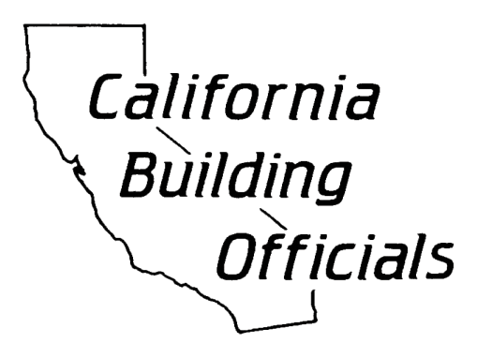

AB 1236 Sample Ordinance Template - Administrative
for Large Jurisdictions

ORDINANCE NUMBER ____
AN ORDINANCE OF THE CITY COUNCIL / COUNTY BOARD OF SUPERVISORS OF THE CITY OF __________ / COUNTY OF __________
SETTING FORTH PROCEDURES FOR EXPEDITING PERMITTING PROCESSING FOR ELECTRIC VEHICLE CHARGING SYSTEMS
WHEREAS, the State of California and the City of __________ / County of __________ has consistently promoted and encouraged the use of fuel-efficient electric vehicles; and
WHEREAS, the State of California recent adopted Assembly Bill 1236, which requires local agencies to adopt an ordinance that creates an expedited and streamlined permitting process for electric vehicle charging systems; and
WHEREAS, creation of an expedited, streamlined permitting process for electric vehicle charging stations would facilitate convenient charging of electric vehicles and help reduce the City’s / County’s reliance on environmentally damaging fossil fuels.

NOW, THEREFORE, THE CITY COUNCIL OF THE CITY OF __________ / COUNTY BOARD OF SUPERVISORS OF THE COUNTY OF __________ DOES ORDAIN AS FOLLOWS:

SECTION 1. TITLE, WORDS AND PHRASES

This Ordinance shall be known as the City of __________ / County of __________ Electric Vehicle Charging Station Permit Expediting Ordinance. The terms, phrases, and words used in this Ordinance shall be construed in compliance with the definitions set forth by California Government Code Section 65850.7.

SECTION 2. Section __________ of the City of __________ Municipal Code / County of _________ County Code is hereby added to read as follows:

Section __________ Expedited Electric Vehicle Charging Station Permitting
Electric Vehicle Charging Stations which qualify for expedited permit processing, pursuant to Government Code Section 65850.7, shall be subject to the administrative permitting procedures set forth in the City’s Electric Vehicle Charging Station Permit Expediting Ordinance.

SECTION 3. EXPEDITED REVIEW PROCESS
Consistent with Government Code Section 65850.7, the Building Official shall implement an expedited administrative permit review process for electric vehicle charging stations, and adopt a checklist of all requirements with which electric vehicle charging stations shall comply with in order to be eligible for expedited review. The expedited administrative permit review process and checklist may refer to the recommendations in the checklist prescribed by the most current version of the “Plug-In Electric Vehicle Infrastructure Permitting Checklist” of the “Zero-Emission Vehicles in California: Community Readiness Guidebook” published by the Governor’s Office of Planning and Research. The City’s / County’s adopted checklist shall be published on the City’s / County’s website.

SECTION 4. ELECTRONIC SUBMITTALS
Consistent with Government Code Section 65850.7, the Building Official shall allow for electronic submittal of permit applications covered by this Ordinance and associated supporting documentations. In accepting such permit applications, the Building Official shall also accept electronic signatures on all forms, applications, and other documentation in lieu of a wet signature by any applicant.

SECTION 5. ASSOCIATION APPROVAL
Consistent with Government Code Section 65850.7, the Building Official shall not condition the approval for any electric vehicle charging station permit on the approval of such a system by an association, as that term is defined by Civil Code Section 4080.

SECTION 6. PERMIT APPLICATION PROCESSING
A permit application that satisfies the information requirements in the City’s / County’s adopted checklist shall be deemed complete and be promptly processed. Upon confirmation by the Building Official that the permit application and supporting documents meets the requirements of the City / County adopted checklist, and is consistent with all applicable laws, the Building Official shall, consistent with Government Code Section 65850.7, approve the application and issue all necessary permits. Such approval does not authorize an applicant to energize or utilize the electric vehicle charging station until approval is granted by the City / County. If the Building Official determines that the permit application is incomplete, he or she shall issue a written correction notice to the applicant, detailing all deficiencies in the application and any additional information required to be eligible for expedited permit issuance.

SECTION 7. TECHNICAL REVIEW

It is the intent of this Ordinance to encourage the installation of electric vehicle charging stations by removing obstacles to permitting for charging stations so long as the action does not supersede the Building Official’s authority to address higher priority life-safety situations. If the Building Official makes a finding based on substantial evidence that the electric vehicle charging station could have a specific adverse impact upon the public health or safety, as defined in Government Code 65850.7, the City / County may require the applicant to apply for a use permit.

SECTION 8. Any provision of the City of __________ Municipal Code / County of __________ County Code or appendices thereto, inconsistent with the provisions of this Ordinance, to the extent of such inconsistencies and no further, are hereby repealed or modified to that extent necessary to effect the provisions of this Ordinance.

SECTION 9. If any section, subsection, sentence, clause, or phrase of this Ordinance is for any reason held to be invalid or unconstitutional by a decision of any court of any competent jurisdiction, such decision shall not affect the validity of the remaining portions of this Ordinance. The City Council / County Board of Supervisors hereby declares that it would have passed this Ordinance, and each and every Section, subsection, sentence, clause, or phrase not declared invalid or unconstitutional without regard to whether any portion of the Ordinance would be subsequently declared invalid or unconstitutional.

SECTION 10. The Mayor shall sign and the City / County Clerk shall attest to the passage of this Ordinance. The City / County Clerk shall cause this Ordinance, or a summary thereof to be published once in the official newspaper within 15 days after its adoption. This Ordinance shall become effective on September 30, 2016.

APPROVED AS TO FORM:

______________________________
NAME
City Attorney / County Counsel

