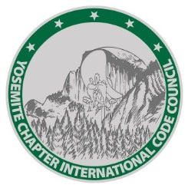 | YOSEMITE CHAPTER INTERNATIONAL CODE COUNCIL  P.O. Box 1525  Modesto, CA 95353  (209) 468-3181  www.yosemitechapter-icc.org | 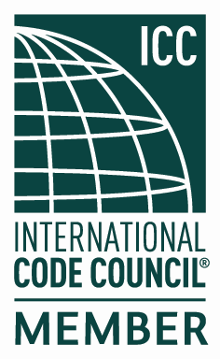

Officers:
President: | Brian Odom | City of Oakdale
Vice President: | Chris Landreth | City of Tracy
Treasurer: | Mike Brinkman | CSG Consultants
Secretary: | Gene Langston | City of Modesto
Board of Directors:
John Schweigerdt | City of Stockton – Past President
Kevin Jorgensen | City of Tracy
Crickett Brinkman | CSG Consultants
Oscar Diaz | City of Modesto
Mike Callaway | City of Turlock

Yosemite Chapter Scholarship Application

PURPOSE: College scholarship(s) in the amount up to $2000.00 will be awarded to a deserving student(s) based on the following considerations: (a) academic ability, (b) community involvement, (c) completed application, (d) oral presentation, (e) panel interview and (f) a minimum 500 word essay on the insights gained and developed through research regarding the true value of a Building Department within a community.

Applications are now being considered for the Yosemite Chapter ICC Scholarship.
YICC is offering a scholarship(s) to be used for education towards a full-time course of studies and shall be limited to students planning to attend a University, College, or Technical School.

Application Criteria and Information:

- Applications will be received from August 1, 2021 through November 15, 2021. Only applications received within that time period will be considered. The Scholarship Committee will review all applications and all awards are made at the sole discretion of the Scholarship Committee.

- Applicants will provide a maximum 5-minute presentation at the November 18, 2021 Chapter meeting telling the ICC Yosemite Chapter membership as to why they are the best applicant to receive the scholarship. Please send email confirming your presentation to kevin.jorgensen@cityoftracy.org by November 15, 2021.

- The top tier of applicants will be interviewed by a Chapter panel prior to final selection(s) to determine the most deserving and qualified candidate.

- Announcements of the award will be made by phone or in writing and the recipients will receive the award at the Yosemite Chapter Annual Banquet in January of 2022. The meal for the recipient will be paid for by the Chapter.

- Awards will not exceed $2000 to any one individual in any single year and the funds must be used within the twelve-month period commencing receipt of the award.

- Applications must be completely filled out and be legible. The following documentation must accompany the application:

a. Course Registration Information

b. Brochure/Documentation Detailing the Course of Study and Estimated Total Cost of the course or program

c. Dates/location of the course

d. Copy of previous semester grades

e. A minimum five-hundred-word essay with the following theme: “What is the Value of the Building Department to the Community It Serves?”

- Applicant is responsible for ensuring that all items listed above are submitted to The Yosemite Chapter International Code Council Scholarship Committee at 333 Civic Center Plaza, Tracy, California, 95376, Attention: Kevin Jorgensen no later than November 15, 2021.

- Points will be awarded for the application, essay, 5-minute oral presentation and panel interview weighted 10%, 20%, 20% and 50% respectively.

- If you have any questions, please contact Scholarship Committee Chair Kevin Jorgensen at kevin.jorgensen@cityoftracy.org.

2021 Yosemite Chapter Scholarship Application

Personal:

Name
Last First Middle

Home
Address
Number & Street City Zip
Phone Number: _____________________Email Address:

Scholastic Information:

Attending College/High School Name

Attending College/High School Address
Number & Street City/State Zip

Phone Number

Anticipated Graduation Date

Provide Names, City and State of colleges and high schools you have attended (most recent first)
Colleges attended
a. From To

b. From To

High School attended

- Graduation Date

In what program do you expect to get your degree?

In what school sponsored extra-curricular activities have you participated while attending high school and/or college?

College

High School

Employment History:
List below any employment you’ve had in the last 4 years, starting with most recent.
- Employer
Dates Employed: From To
Job Title
Work Performed
Employer Contact Information
- Employer
Dates Employed: From To
Job Title
Work Performed
Employer Contact Information
- Employer
Dates Employed: From To
Job Title
Work Performed
Employer Contact Information

Description of your goals and aspirations:

List any community activities you have been involved in and your role and/or participation:

